The PLANTATION
PRESS

Slaves Being Mistreated
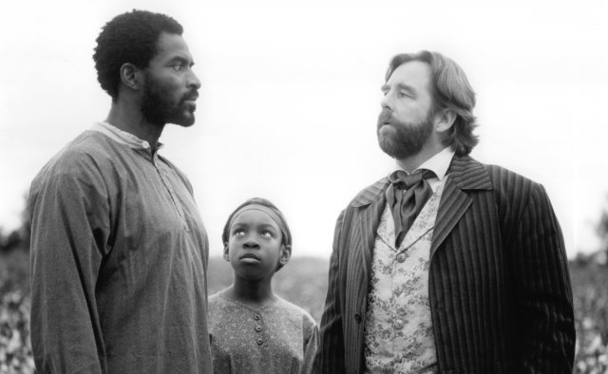
* Slave owner Clel Waller with John and Sarny right before he cuts off his toes.
-by: Danny Ampong- October 29, 1834

ON a warm Tuesday afternoon in 1834, slaves John, Sarny, and Mammy were subjected to cruel and unusual punishment just for reading and writing. in the beginning of this unnecessary incident it started with John coming to the plantation after being sold and teaching Sarny to read and write. The two had to learn in secret because slave owners hate it if there “property” can read and write. No matter the risk and the penalty, John continued to teach Sarny even though they would soon be caught. John and Sarny should be celebrated for their bravery, not be punished for it.

